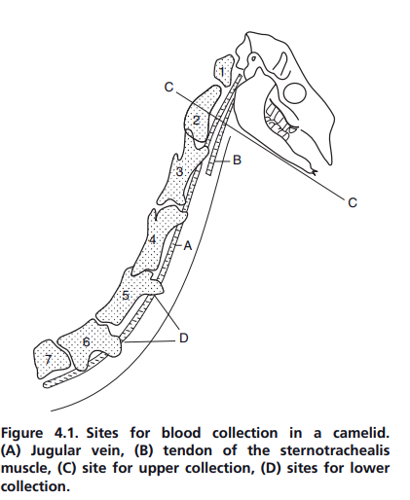
Figure 1. Sites for blood collection in a camelid. (A) Jugular vein, (B) tendon of the sternotrachealis
muscle, (C) site for upper collection, (D) sites for lower collection.

